**Description**

As a user, if I already have an account on MoneyTree, I should be able to successfully login and be able to view my Dashboard and my financial information shown represented by various graphs. The 4 graphs I should see are the baseline (Progress Bar), Total Spending for the year (Categories from Plaid API), Cash Flow (Line Graph) and Transaction Detail – from last 30 days. I should have the option to Edit my Profile as well.

------------------------------------------------------------------------------------------------------------------------------------------

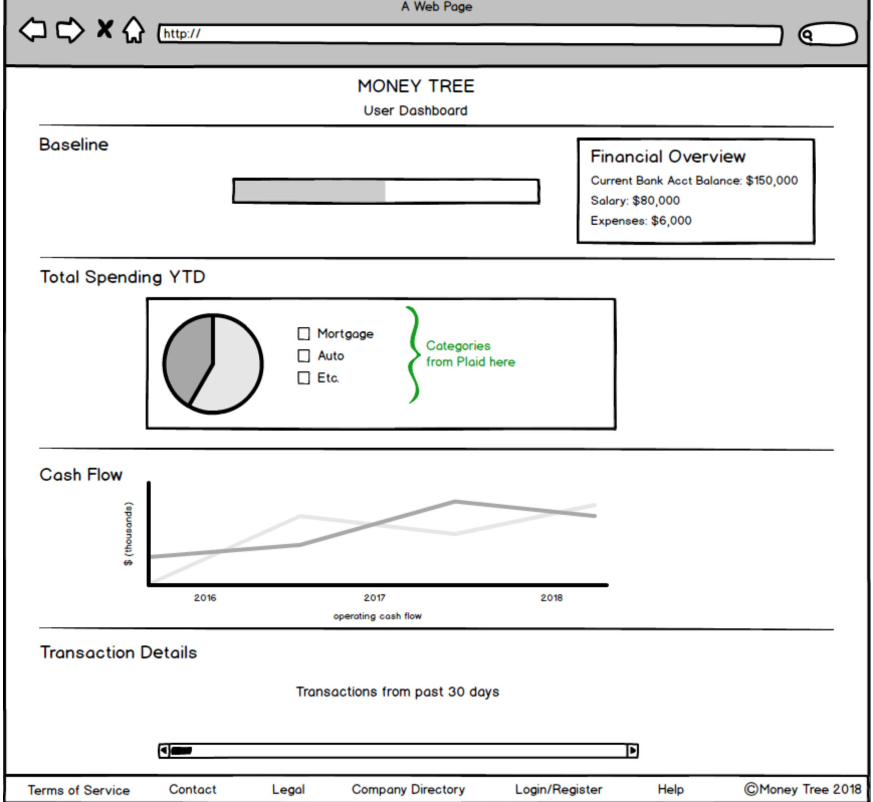

**Acceptance criteria**

* Tamagotchi should successfully be able to change it’s appearance/mood based on how the user financials are
* Display graph for Baseline story – Should successfully represent how much money is remaining for the month?
* Display graph for the total Spending for 2018. Should successfully represent the categories from the Plaid API based on the user selected Bank and reflect the numbers in a Pie Chart.
* Display graph for Cash Flow (Line Graph)
* Display chart for Transactions from last 30 days.